**Week 11**

# 1.Create view and query 2. Create users and assign privileges for DB operations

**Working with views**

View is a virtual table created from parent tables. It is based on the result-set of an SQL statement. A view contains rows and columns. We can create a view by selecting fields from one or more tables. Views are not executed when they are created. They are executed when they are referenced. Each time you reference the view in the query, it is run again. It is used to hide some data from unauthorized users and create a child table.

**Table student:**

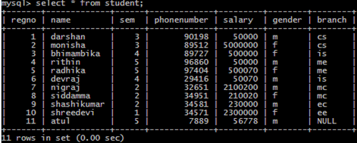

**Creating a view from parent table student**

mysql>Create view v3 as select name, gender, branch, sem from student;

**To see data in view**

mysql>select * from v3 ;

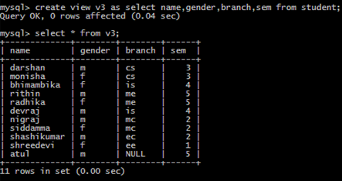

**To see specific data in a view**

mysql>select * from v3 where gender = ’ f ’;

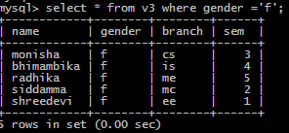

**To delete from view( data is deleted from parent table also)**

**mysql>** delete from v3 where name=’rithin’;

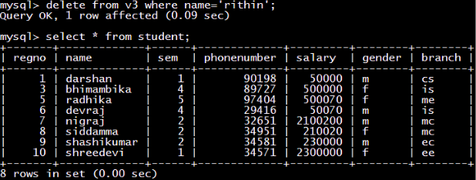

**To update from view( data is updated in parent table also)**

**mysql>** update v3 where set sem =1 where name= ’darshan’;

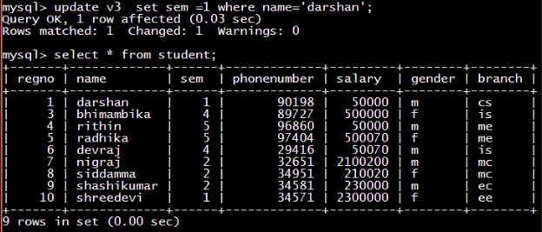

**DCL commands**

* The DCL (Data Control Language) commands are used to control the access to the database objects like Tables, Views, Stored Procedures, etc.
* It is related to security.
* The DCL commands are:
* GRANT
* REVOKE
* Creating New User:

mysql> use mysql;

mysql> select user from user;

mysql> create user dbms;

mysql> select user from user;

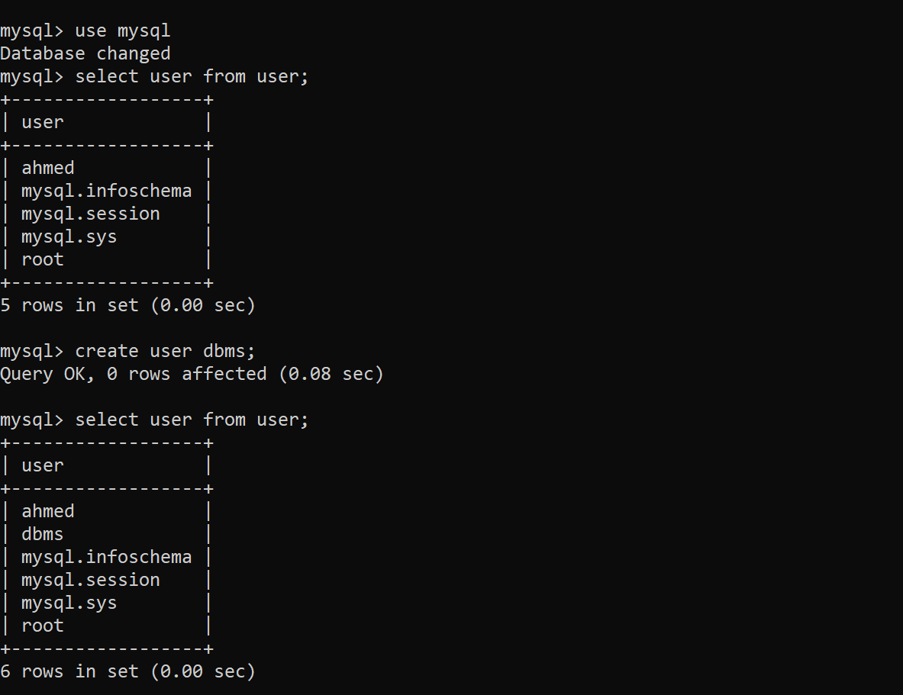

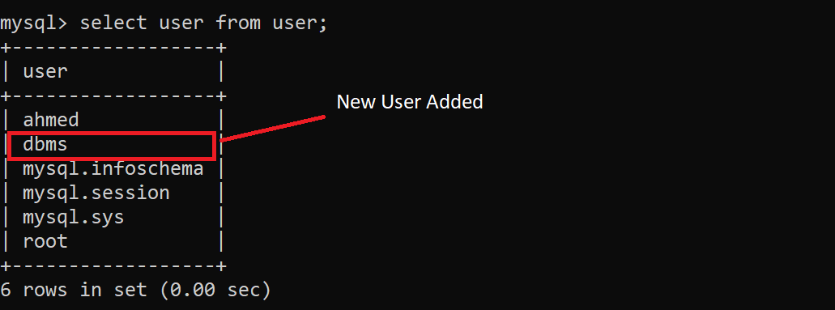

* GRANT:
* It is used to give access to the users.
* It allows users to perform specific tasks.

**General Syntax:**

GRANT privilege_name on object_name

to {user };

where:

* Privilege_name - Select, Insert, Delete, Alter, All, etc.
* Object_name - Tables, views, etc.

mysql> GRANT insert on ahmed.student to dbms;

mysql>GRANT select on ahmed.dept to dbms;

mysql> GRANT update on dept to dbms;

mysql>show grants for dbms;

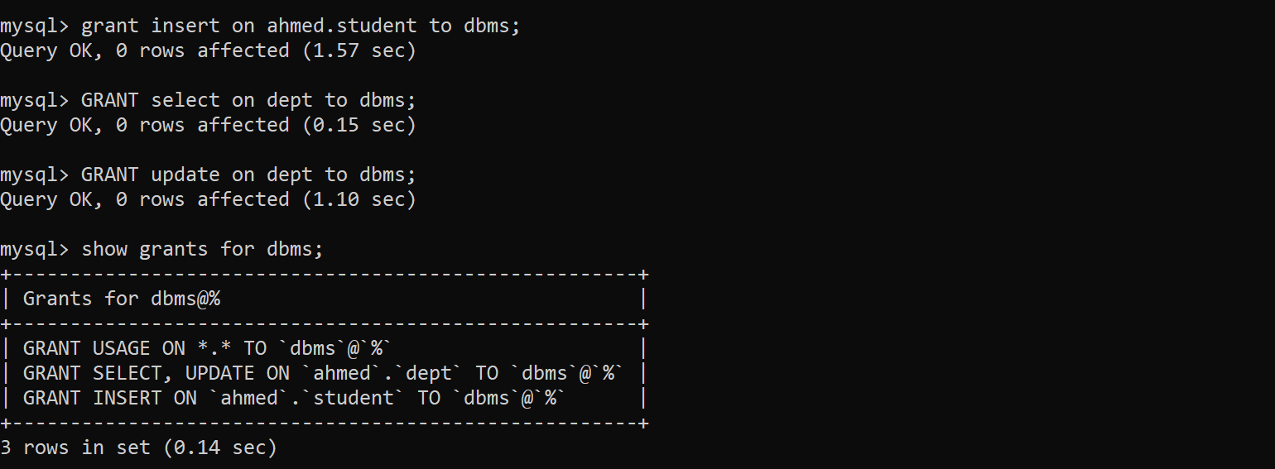

* REVOKE:
* It is used to deny access from the users.

**General Syntax:**

REVOKE privilege_name on object_name

FROM { user };

here:

* Privilege_name - Select, Insert, Delete, Alter, All, etc.
* Object_name - Tables, views, etc.

mysql>REVOKE insert on ahmed.student from dbms;

mysql> REVOKE select on dept from dbms;

mysql> show grants for dbms;

